**Experiment – 2.1(c)**

**Student Name: Milan Sharma UID: 23MAI10003**

**Branch: ME – CSE - AIML Section/Group: MAI – 1 (A)**

**Semester: 1st Date of Performance: 04 Oct 2023**

**Subject Name: Python Programming Subject Code: 23 CSH 623**

1. **Aim of the Experiment :**

Write a python program to perform list slicing

1. **Objective of the Experiment :**

To perform list slicing

1. **Algorithm/ Steps for Experiment**

1.        In Python List, there are multiple ways to print the whole List with all the elements, but to print a specific range of elements from the list, we use Slice operation.

2.        Slice operation is performed on Lists with the use of a colon(). To print elements from beginning to a range use [: Index], to print elements from end-use[index], to print elements from specific Index till the end use [Index:], to print elements within a range, use [Start Index: End Index] and to print the whole List with the use of slicing operation, use [:].

3.        Further,to print the whole List in reverse order, use [::-1].

4.        Note– To print elements of List from rear end, use Negative Indexes.

1. **Code for Experiment :**

List = ['G','E','E','K','S','F', 'O','R','G','E','E','K','S']

print("Initial List: ")

print(List)

Sliced_List = List[3:8]

print("\nSlicing elements in a range 3-8: ")

print(Sliced_List)

Sliced_List = List[5:]

print("\nElements sliced from 5th element till the end: ")

print(Sliced_List)

Sliced_List = List[:]

print("\nPrinting all elements using slice operation: ")

print(Sliced_List)

1. **Result/Output :**

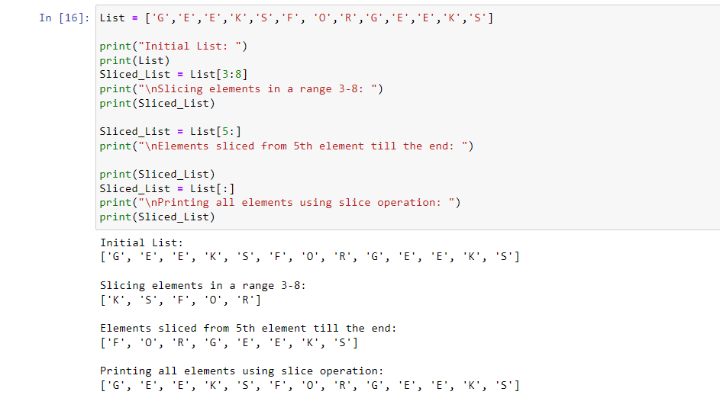

**Learning outcomes (What I have learnt):**

1. Learnt different operations performed on list.
2. Learnt the different in-build function that are performed on list
3. Learnt functions like len(), pop() etc.
4. Imported a new library named Collection and know about it.
5. Learnt how to slice the list

**Evaluation Grid (To be created as per the SOP and Assessment guidelines by the faculty):**

|  |  |  |  |
| --- | --- | --- | --- |
| **Sr. No.** | **Parameters** | **Maximum Marks** | **Marks Obtained** |
| **1.** | **Student Performance**  **(Conduct of experiment)**  **Objectives/Outcomes.** | 12 |  |
| **2.** | **Viva Voce** | 10 |  |
| **3.** | **Submission of Work Sheet**  **(Record)** | 8 |  |